Document Number | HPL2
Document Title | AAP Therapist
Department Ownership | Hand and Upper Limb
Document Type | Policy
Department Owner | Tim Darch
Document Author | Derrick Chan
Last Edited By | Nick Filevski | Lasted Edited On | 02/12/2014

The purpose of this policy is to outline the guidelines in regards to performing AAP tasks

Any staff members who undertake AAP procedures

REDiMED Infection Control Policies:

- Hand hygiene

- Needle stick injury

- Blood contents and bodily fluids

- Incident report form

APA Guidelines for Safe Acupuncture

WA Health Skin Penetration Procedure 1998

- Principles of AAP

Acupuncture approaches have been practiced for 3000-5000 years, which are largely based on Chinese Medical techniques. Traditional techniques may not necessary correspond to Western medical anatomy, therefore the method practiced, as taught by Doug Cary, is referred to as AAP.

AAP optimizes location and depth to stimulate group IV muscle nociceptors, eliciting an aching sensation in a muscle treatment area. Through aiming for myofascial trigger points (MTrP), hyperirritable spots in a skeletal muscle, AAP can effectively treated a wider area range with fewer insertions and therefore less discomfort than other dry needling approaches.

- Benefits of AAP
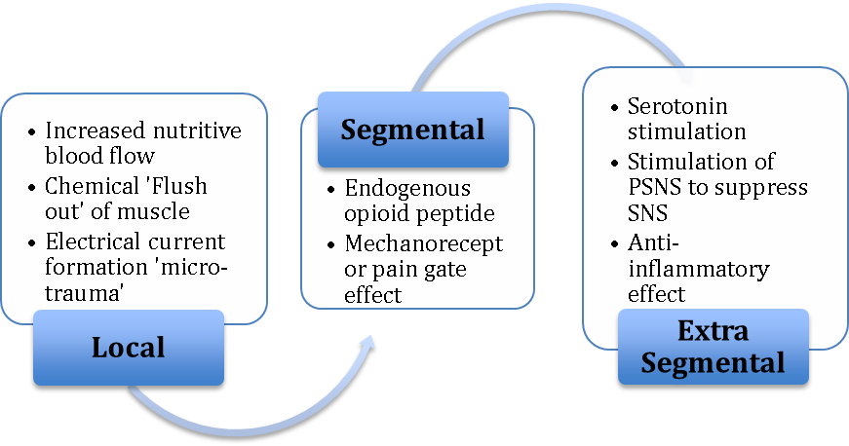

Considering dry needling is a noxious stimuli and a passive treatment, it has the potential to exacerbate chronic pain patterns, therefore thorough assessment is required prior to treatment and should be embedded in a broader client centred plan, including self-management strategies.

- Assessment

Determining a client’s suitability for AAP should include consideration of current occupational issues, medical history and psychological wellbeing. Therapists must apply clinical anatomy knowledge to palpate identified muscles and localize trigger points. Reliable and valid outcome areas may include:

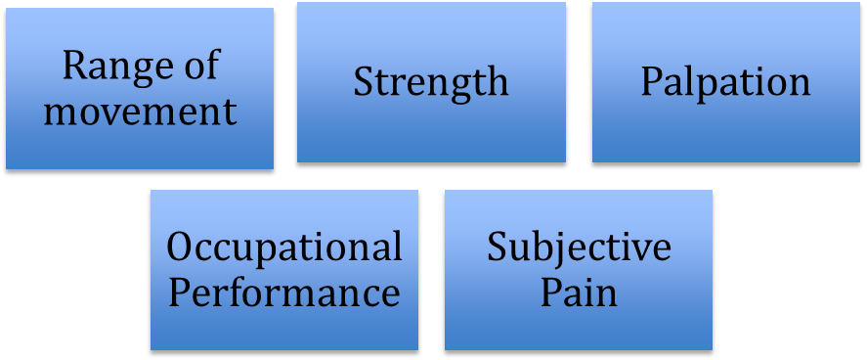

Medical considerations should include:

- Pregnancy

- Infected tissue, frail skin, malignancy

- Needle phobias and metal sensitivity

- Anatomical limits e.g. Scapula fossa

- Epilepsy, haemorrhagic disease, low immune system

- Anticogulant therapy

- Implants (cosmetic)

- Safe Practice Methods

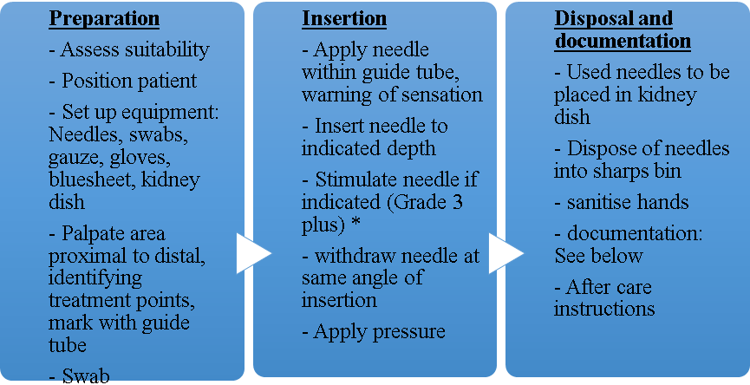

* The minimum amount of stimulation should be used to achieve a relaxation effect in the muscle

- Documentation and Medico legal considerations

  - Documentation:

Documentation must include consent, area needled and grade.

E.g. ECG (Explain, consent gained)
WGU (Warnings given and understood)
Flexor forearm*
3 points
Grade I/II
Post care stretches provided.
Patient reported decreased pain

* Therapist reasoning will determine anatomical detail required, from a specific muscle to an anatomical region, depending on range treated and relevance to future treatments.

  - Medico-legal

The minimum legal requirements to practice AAP in a clinical setting according to the ADNG guidelines (APA national group) is a 2-day course/150 hours training. This must be limited to the treatment areas covered in the course. Due to Occupational therapists being included in AHPRA national registration, it is particularly important to treat within our professional scope and to practice under the title of an Occupational Therapist only.

The WA health department policy on skin penetration mandates:

- Aseptic procedure (Swabbing)

- Single use sterile needles

- Correct needle disposal

- Complementary treatment modalities

- Musculoskeletal OT

- Cupping

- Scraping/Gua Sha

- Heat/Cold modalities

- Inter X

- Range of movement exercises

- Functional activity

- Aerobic exercise

- Troubleshooting

Management of Adverse Reactions:

- Persistent pain
Remove Needles
Apply heat/ice

- Haematoma
Avoid blood vessels
Apply ice to minimize bruising

- Fainting
Thorough assessment prior to treatment; e.g. lying position, lower grade of stimulation
Remove needles, lay patient down and offer drink/food

- Stuck/Bent Needle
Avoid twisting needle or needling tendinous muscle
Try relaxing tissue around needle e.g. massage, or insert ‘star’ configuration of needles around site

- Broken Needle
If exposed, remove with tweezers, otherwise seek medical attention

- First episode seizures
Remove needles
Lay patient down and support head if possible (Do not restrain)
Seek medical assistance

- Pneumothorax
Symptoms e.g. SOB may not occur until several hours after treatment so patient education is very important. If symptoms occur, patient should seek urgent medical attention.

- Infection Control

